Herdsman Lake Food Web
Herdsman Lake supports a variety of wild life.
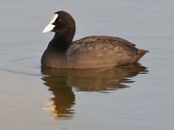
A biologist doing field work noticed the following:
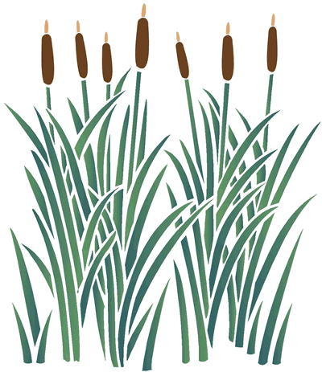
- Tiger snakes eating frogs, coots and the odd small duck
- Swamp hens eat bullrushes and lawn
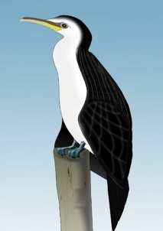
- Coots eating water weeds and lawn
- Fish eating water weeds
- Cormorants eating fish
- Pelicans eating fish and small coots
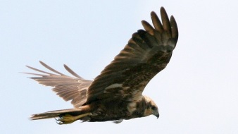
- Caterpillars eating bullrushes
- Frogs eating caterpillars
- Harriers eating coots and frogs
- Ducks eating water weeds and small fish

Construct a food web to show the relationships above.
Label each tropic level.
How would you add decomposers to your food web?

